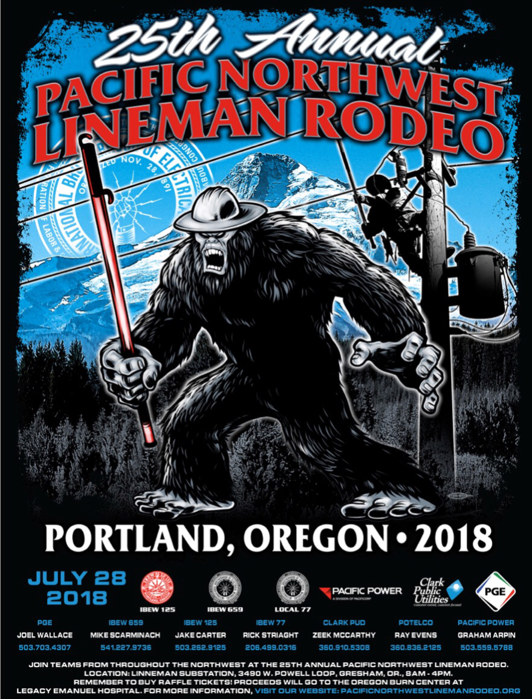

Northwest Pacific Lineman Rodeo
July 28, 2018 Vendor Registration
The Northwest Pacific Lineman Rodeo, sponsored by PGE, PacifiCorp, Potelco, Clark PUD, IBEW Locals 125 and 659, and planning committee would like to thank you for your participation and interest in this year’s event. The 2018 Lineman’s Rodeo will again be held at:

Portland General Electric’s Lineman Substation
3450 W. Powell Blvd.
Gresham, OR 97230

The Vendor Fee for this year’s rodeo is $100; door prizes are optional. Spaces may be limited, so please reply prior to July 14, 2018.

Tents (10’ x 10’) are available for extra door prizes - make sure we know ahead of time as we may run out.

If you desire a larger tent, 10’ X 20‘ tent rentals are available through Key Manufacturing & Rentals. Quoted prices are $195/day for a 10’ X 20’ tent. Please contact the tent supplier if you choose to have one set up, and let us know what size you will use, so we’ll know the space you will need. If you use the tent supplier, please make arrangements to pay them directly, not through the Rodeo Association. Availability is limited due to busy season, reserve as soon as possible; contact Chuck Krieger at 503-307-3759, email at: chuck.krieger@terex.com.

Electricity is available but limited, so please indicate if you will require it at your booth. Should you have any special requirements, please contact us and we will make every effort to accommodate your requests.

Please fill out and return form to: Northwest Pacific Lineman’s Rodeo Association
17200 NE Sacramento St.
Portland, OR 97230
Attn: Joel Wallace

Company Name: _______________________________________________________

Address: _____________________________________________________________

City: _______________________ State: ___________________ Zip: __________

Contact Person: ______________________________ Phone: __________________

Weblink: _____________________________________________________________

Will you be using a 10’ x 10’ tent in exchange for extra door prizes? YES / NO

Will you be ordering a larger tent from Northwest Tents and Events? YES / NO Size: 10’ X 20’

Will you require electricity? YES / NO

Opening Ceremonies begin at 8:00a.m. We look forward to seeing you and again thank you for your interest.
Northwest Pacific Lineman’s Rodeo Association Planning Committee

